Documentation of <https://www.irakuharry.me>

As per the requirements given by the instructor, I have designed and developed this personal website to provide basic information about myself. This website will provide the following services:

1. Present information about the author.
2. Store images owned by the author.
3. Provide the visitor with a form to contact the author.
4. Provide a brief description of the website design in this documentation which is downloadable.

This website is static and displays the same information for all visitors from all contexts and personalization is impossible.

I began my development with a simple design in MS Paint for the two web pages, as shown in the figure below.

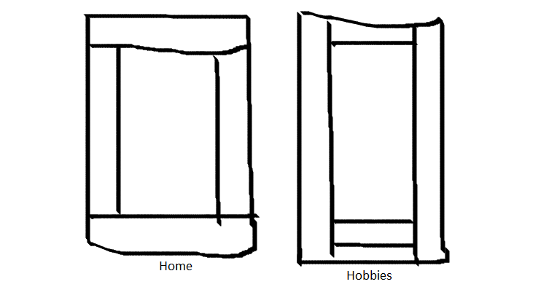

1. Design of the Home and Hobbies web pages.

There are several IDEs available for building web pages but per the instructor’s suggestion, I used MS Notepad to write the underlying HTML5 code. No CSS or JavaScript codes were included in the source file.

Inside the head element, I included attributes to provide information about the page’s author, facilitate faster discovery of the site by search engines and portability for devices of all display sizes.

Since I restricted the development of the pages to only HTML5, I used the table elements to build the layout shown in figure 1.

I tried to use the basefont tag to set the base font of the whole page but it failed, so I resorted to the font tag and set it to Lucida Calligraphy with the alternates as Verdana and Sans-serif in that order.

The main section contains elements such as headings, navigation section, paragraphs, a table, lists, several images (one is set as the banner at the top of the home page), hyperlinks (that link to either link to within the same page, another page on the same site or to external sites), a form to generate inquiries from the visitors (it launches the local web client of the platform upon clicking the Submit button) and an inline frame that displays this word document for the visitor to peruse (the visitor has an option of downloading this document on to their device). I set the backgrounds of the side panes as images using the background attribute.

The saved .html files were tested with Google Chrome on a Windows 10 platform.

Upon completion of the assignment, I created an account on GitHub.com, edited the generic README file for all my projects and uploaded the web pages and accompanying resource files such as the images and document file.